FOR IMMEDIATE RELEASE

Arkansas Soybean Promotion Board
Commemorates Arkansas Soybean Month

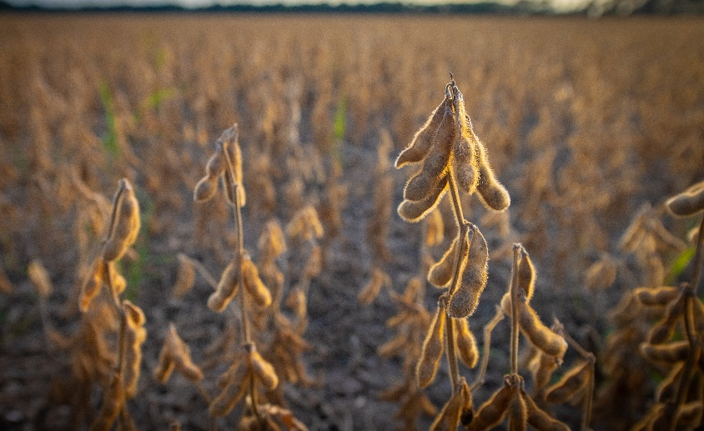

Governor Hutchison Proclaimed November as Arkansas Soybean Month.

LITTLE ROCK, Ark. (November 3, 2022) – The Arkansas Soybean Promotion Board (ASPB), a producer led organization serving the state’s soybean industry through research, education and promotion, is celebrating Arkansas Soybean Month this November. Gov. Asa Hutchinson proclaimed November Arkansas Soybean Month to honor soybean producers and recognize the significance of the soybean industry’s contributions to the Arkansas economy.

“Agriculture is Arkansas’s largest industry and soybeans are our largest row crop,” said Arkansas Department of Agriculture Secretary Wes Ward. “Arkansas Soybean Month allows us to recognize soybean producers and the impact they have on the agriculture industry in Arkansas.”

Soybean production represents a $2 billion industry in Arkansas with approximately 3 million acres planted each year across the state. Fifty-percent of soybeans produced in state are exported each year, enabling Arkansas to consistently rank among the top 10 soybean producing states in the nation.

“Soybeans are a versatile crop that supports multiple agricultural industries and is crucial to the Arkansas agriculture industry,” said Lincoln County soybean producer and Arkansas Soybean Promotion Board Chairman John Freeman. “Arkansas Soybean Month creates an opportunity for us to celebrate the crop, the producers and the contributions of the soybean industry to our state’s economy and the world.”
The Arkansas Soybean Promotion Board was established in 1971 after the Arkansas General Assembly passed Act 259, providing soybean producers in Arkansas an organization through which they could work to improve the state’s soybean industry. The legislation created a nine-member board with the
responsibility of administering research, promotion and market development to foster the growth of Arkansas’s soybean industry. Members are nominated by certain soybean-related organizations and appointed by the governor.

The Board’s activities are funded by the soybean checkoff, a congressionally mandated assessment on soybeans specifically designated for research and promotion efforts.

The Board has planned activities to celebrate Arkansas Soybean Month. For recipes, tools and information to help you celebrate Arkansas Soybean Month, visit the webpage here. Follow the Arkansas Soybean Promotion Board on Facebook, Instagram and Twitter or sign up to receive the monthly Bean Brief newsletter to stay updated on all activities.

To learn more about the Arkansas Soybean Promotion Board, visit TheMiracleBean.com.
###

About Arkansas Soybean Promotion Board
The Arkansas Soybean Promotion Board is led by nine volunteer farmer-leaders nominated by various producer organizations in Arkansas and appointed by the Governor. Soybeans are Arkansas's top row crop with approximately 3 million acres planted each year, generating an annual economic impact of $2 billion. Arkansas is consistently ranked among the top ten soybean producing states nationally, exporting 50% of its crop. ASPB invests more than $2.2 million in research each year as part of its commitment to the continued sustainability of the Arkansas soybean industry. Learn more by visiting TheMiracleBean.com.

